ASSIGNMENT – 46

COUNT A PARTICULAR COLUMN:

select count(emp_id)

from employees;

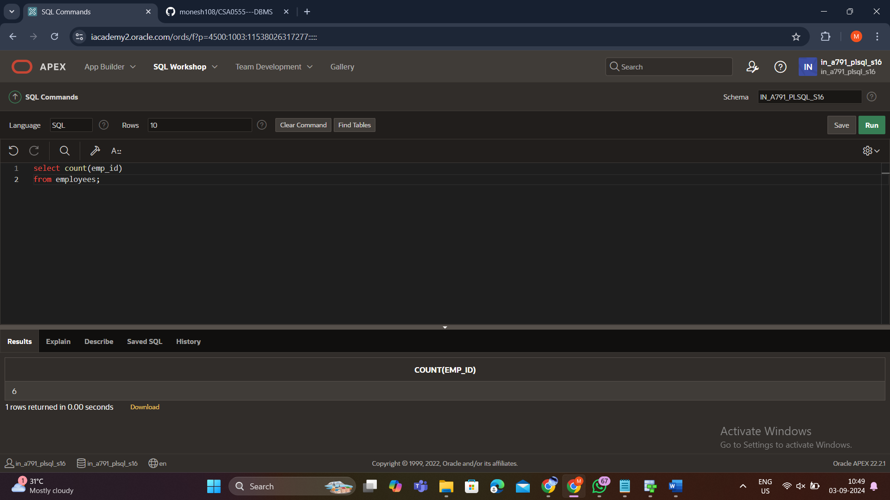

COUNT THE NO OF ROWS IN A TABLE:

select count(*)

from employees;

